## **STORAGE MONITOR DASHBOARD**

# **Snowsight Dashboard Setup**

## 1. Create a Dashboard

Login to the account and navigate to the **tab dashboard** in the left side options ,then click on the **+dashboard** option highlighted in blue to create a new dashboard.

## 2. Name the dashboard

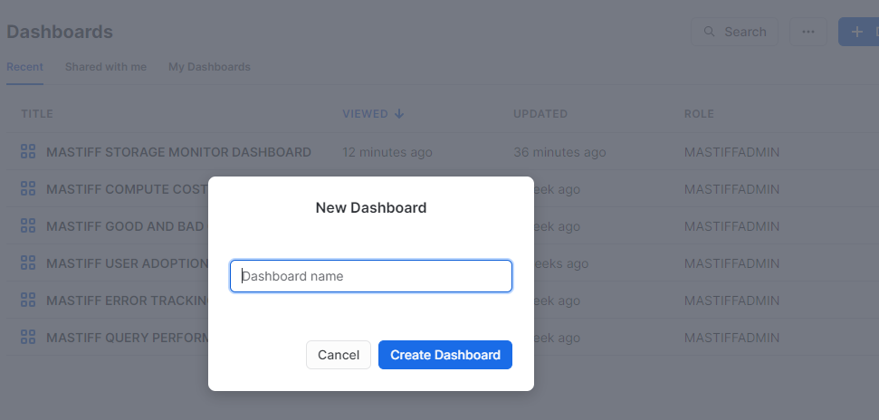

Next step is to give an appropriate name to the dashboard and click **Create Dashboard**.

## 3. Setup the Role and Warehouse

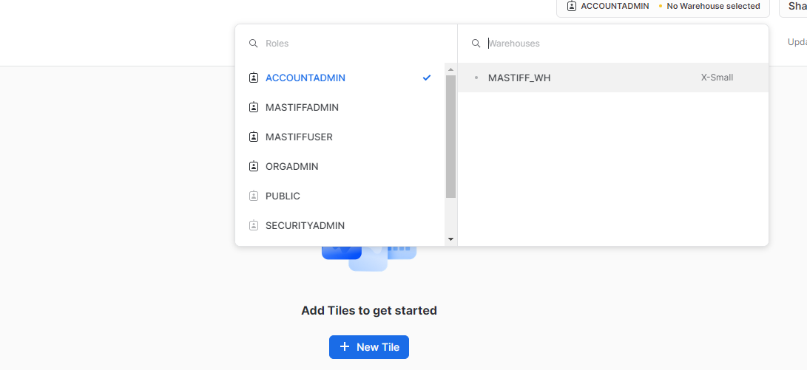

## 4. Creating KPIs and Charts

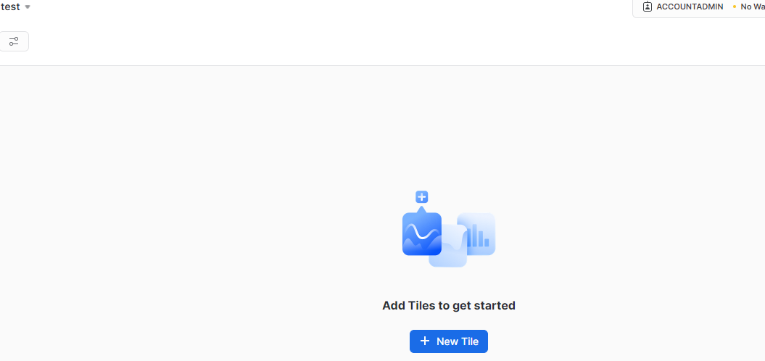

To create KPIs and charts, start by adding a new tile by clicking **+New Tile .**

## 5. Adding names to the KPIs and Executing the queries.

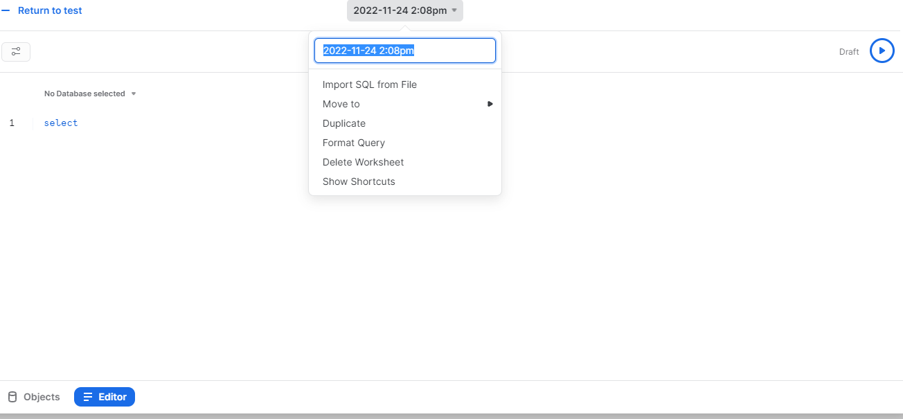

We can name the KPI by clicking the date followed by the time and changing it to the required name. To execute a query, type in the editor and click the run button to get the desired results.

**Note :** Before you create all the dashboards in Snowsight, Use the role **MONITOR_ADMIN** and warehouse **MONITOR_WH** to create dashboards in SNOWSIGHT for Watchkeeper.

## **STORAGE MONITOR DASHBOARD SETUP**

### **1 Total Active Storage TB**

SELECT round(sum(STORAGE_TB),6) FROM "MONITOR_DB"."STORAGE_MONITOR_SCHEMA".ACCOUNT_STORAGE

WHERE USAGE_DATE = (SELECT MAX(USAGE_DATE) FROM "MONITOR_DB"."STORAGE_MONITOR_SCHEMA".ACCOUNT_STORAGE);

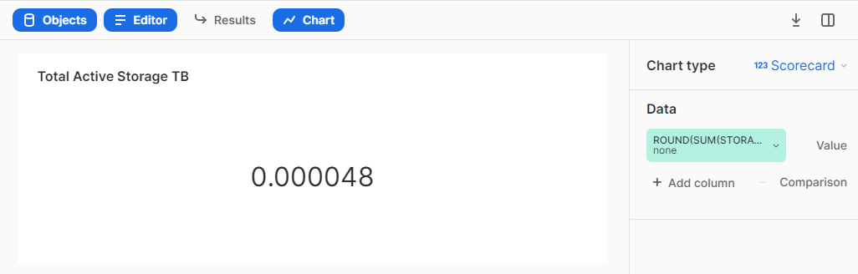

### **2 Total Stage Storage TB**

SELECT round(sum(STAGE_TB),6) FROM "MONITOR_DB"."STORAGE_MONITOR_SCHEMA"."ACCOUNT_STORAGE"

WHERE USAGE_DATE = (SELECT MAX(USAGE_DATE) FROM "MONITOR_DB"."STORAGE_MONITOR_SCHEMA"."ACCOUNT_STORAGE");

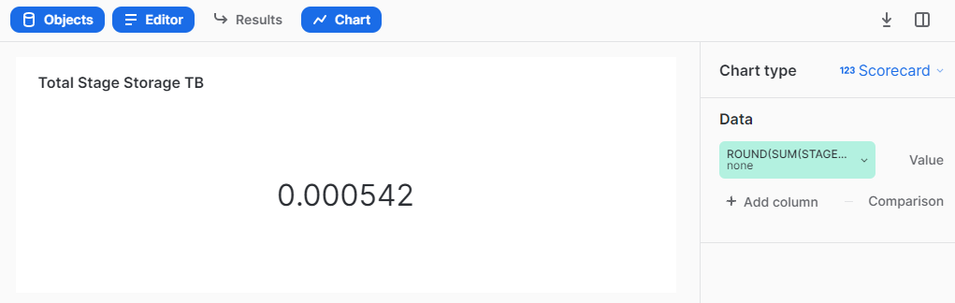

### 

### **3 Total Time Travel Storage TB**

SELECT round(SUM(TIME_TRAVEL_GB)/1024,6) AS TIME_TRAVEL_TB FROM "MONITOR_DB"."STORAGE_MONITOR_SCHEMA".TABLE_AND_SCHEMA_STORAGE;

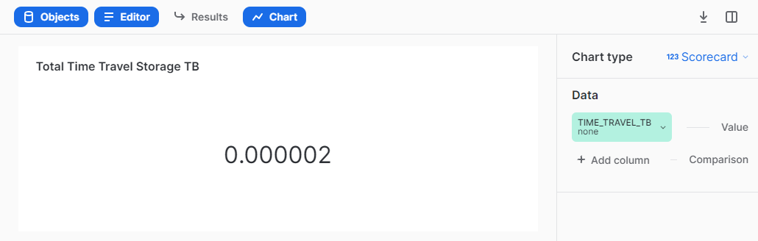

### 

### **4 Total Failsafe Storage TB**

SELECT round(sum(FAILSAFE_TB),6) FROM "MONITOR_DB"."STORAGE_MONITOR_SCHEMA"."ACCOUNT_STORAGE"

WHERE USAGE_DATE = (SELECT MAX(USAGE_DATE) FROM "MONITOR_DB"."STORAGE_MONITOR_SCHEMA"."ACCOUNT_STORAGE");

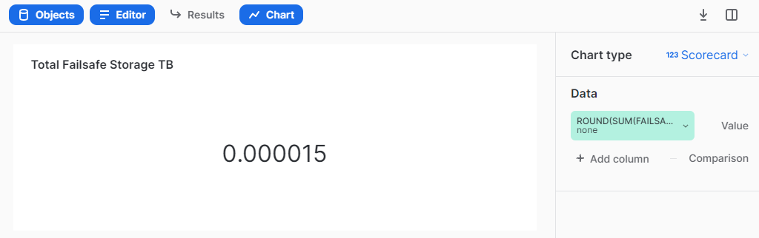

### 

### **5 AVG STORAGE USED**

SELECT ROUND(AVG( STORAGE_TB + STAGE_TB + FAILSAFE_TB ),6) FROM "MONITOR_DB"."STORAGE_MONITOR_SCHEMA"."ACCOUNT_STORAGE" AS AVG_STORAGE_USED ;

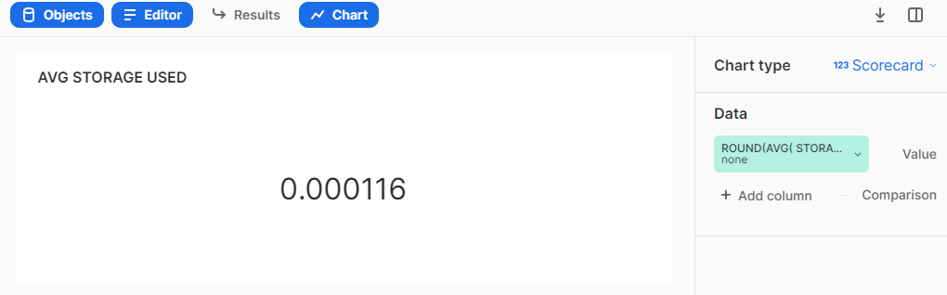

### 

### **6 ORGANIZATION STORAGE USAGE**

SELECT * FROM "MONITOR_DB"."STORAGE_MONITOR_SCHEMA"."ORG_STORAGE" ;

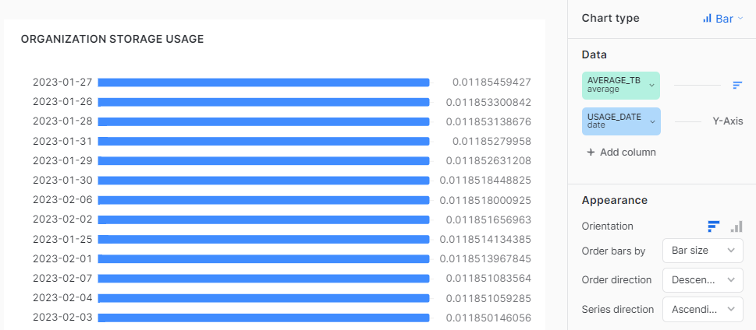

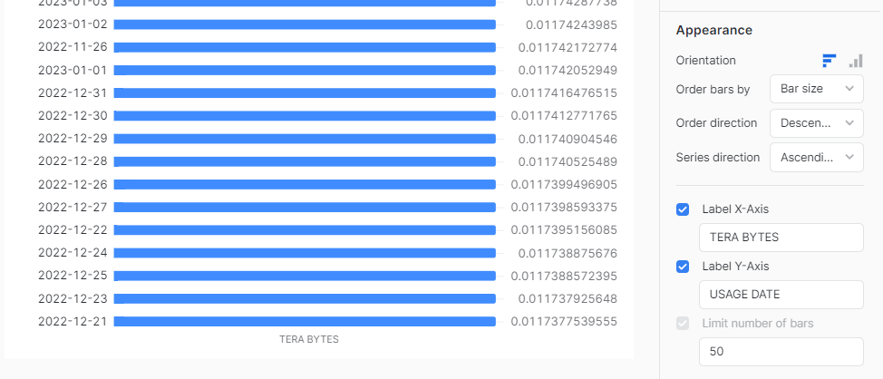

### **7 ACCOUNT STORAGE USAGE**

SELECT * FROM "MONITOR_DB"."STORAGE_MONITOR_SCHEMA"."ACCOUNT_STORAGE" ;

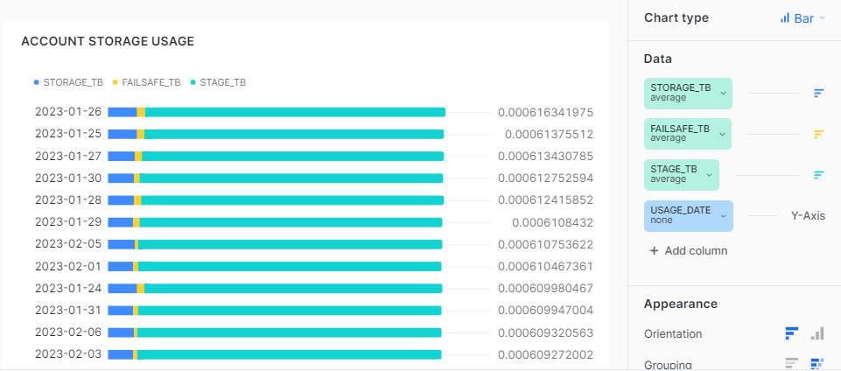

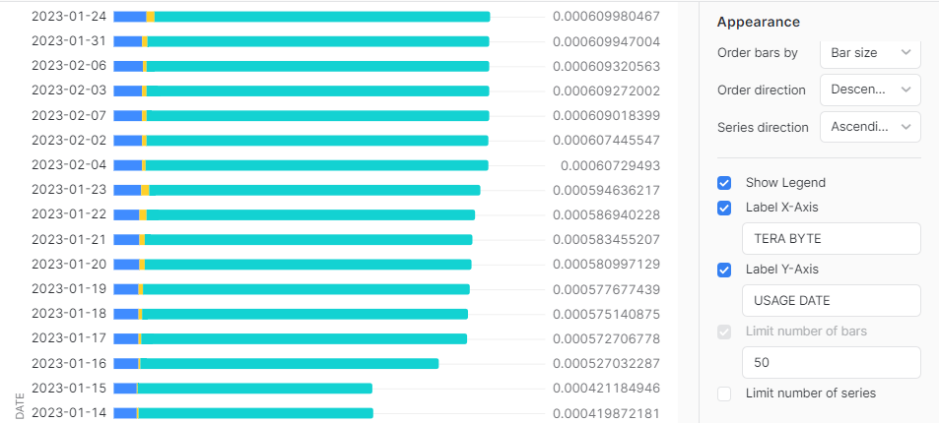

### 

### **8 DATABASE STORAGE USAGE**

select * from "MONITOR_DB"."STORAGE_MONITOR_SCHEMA"."DB_STORAGE";

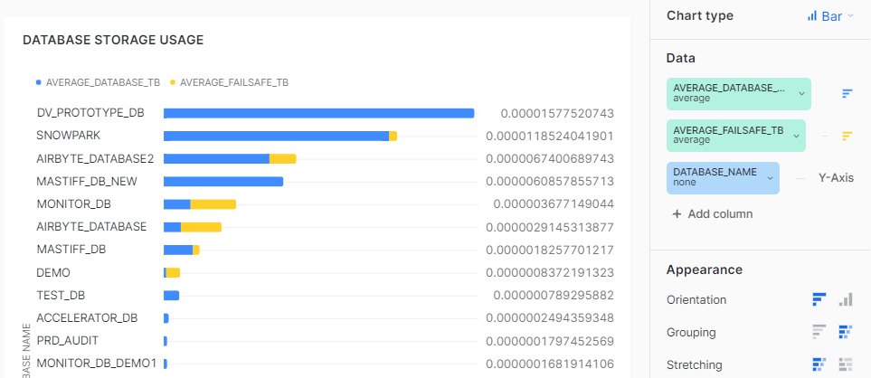

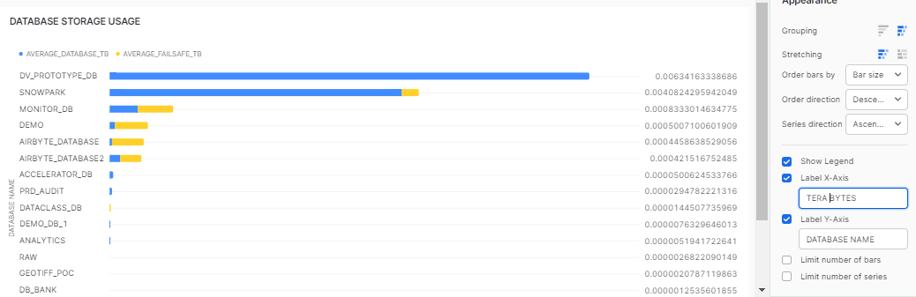

### **9 SCHEMA STORAGE USAGE**

select TABLE_SCHEMA,TABLE_DATABASE, COUNT(TABLE_NAME) AS ACTIVE_TABLE_COUNT, COUNT_IF( IS_TRANSIENT = 'YES') AS TRANSIENT_TABLE_COUNT, COUNT_IF( IS_TABLE_DELETED = TRUE) AS DELETED_TABLE_COUNT, SUM(ACTIVE_GB) AS ACTIVE_GB, SUM(FAILSAFE_GB) AS FAILSAFE_GB, SUM(TIME_TRAVEL_GB) AS TIME_TRAVEL_GB, SUM(RETAINED_FOR_CLONE_GB) AS RETAINED_FOR_CLONE_GB from "MONITOR_DB"."STORAGE_MONITOR_SCHEMA"."TABLE_AND_SCHEMA_STORAGE"

-- WHERE IS_TABLE_DELETED = FALSE -- Change to TRUE to get undeleted tables

GROUP BY TABLE_SCHEMA,TABLE_DATABASE

ORDER BY 1;

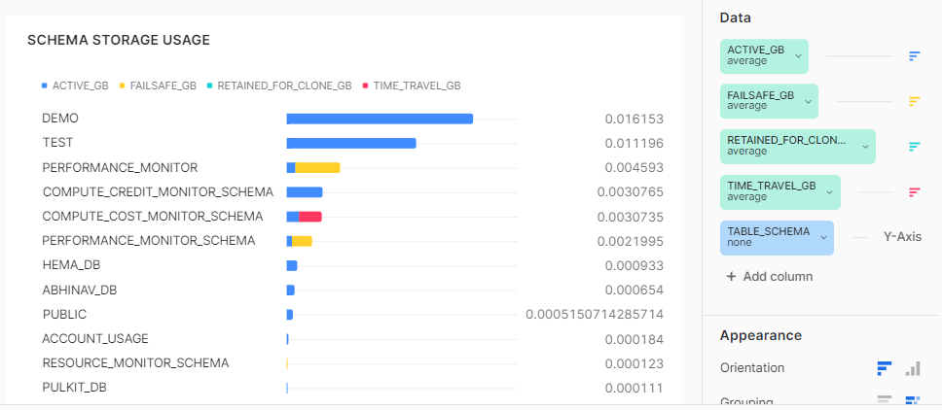

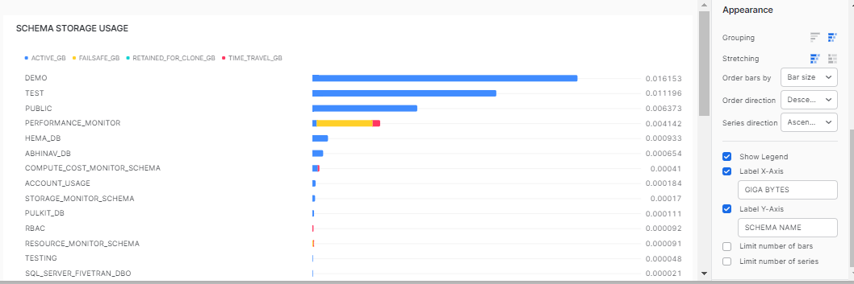

### **10 TABLE STORAGE USAGE**

Select * from "MONITOR_DB"."STORAGE_MONITOR_SCHEMA"."TABLE_AND_SCHEMA_STORAGE" ;

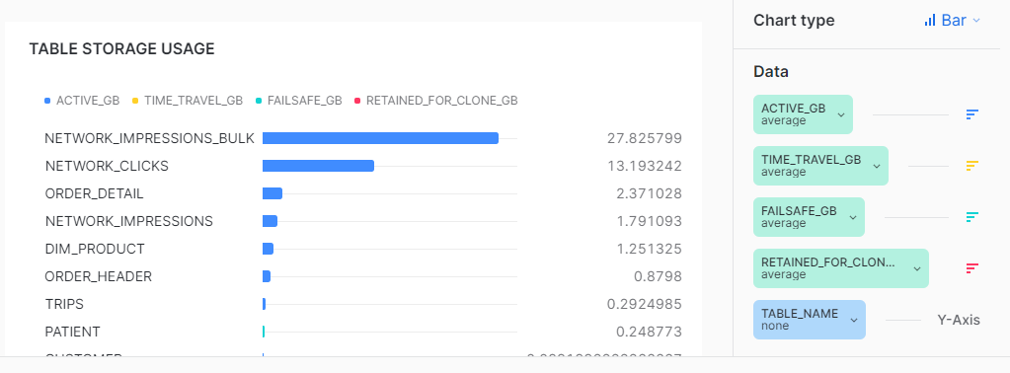

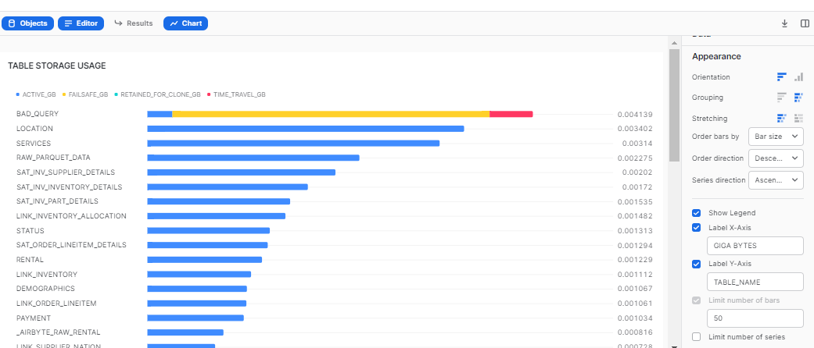

## **Best Practices -**

* If you have records more than 10000 then select only top 9999 ( refer. link:- <https://docs.snowflake.com/en/sql-reference/constructs/top_n.html>) to create a chart as Snowsight only supports data to be visualized till 9999 rows.
* It's preferable to do aggregation in the query itself rather than to do it in Snowsight UI.
* Adjust the round off value as per your requirement ( e.g - round((<column_name>), n) where n = natural number ).
* On hovering over any filter, visuals getting filtered would be highlighted.
* To make filter interaction more user friendly, you can even use color coding.